**(Model SOP)**

**United States Army**

**Name of the Clinic**

**Occupational Health**

**(OFFICE SYMBOL) SOP No.______**

**Effective Date_____**

**Date Removed from Service_____**

**MEDICAL SURVEILLANCE - WELDERS**

**1. PURPOSE**

To define and provide guidance to the employees of (name of clinic / facility) regarding medical surveillance of DoD welders at (name of installation).

**2. AUTHORITY AND REGULATORY COMPLIANCE**

Federal and DoD/DA regulations regarding medical surveillance for welders are listed below in the References section of this SOP.

**3. REFERENCES**

1. 29 CFR 1910 Subpart Q, Welding, Cutting, and Brazing
2. NMCPHC-TM OM 6260, Medical Surveillance Procedures Manual and Medical Matrix (“Navy Medical Matrix”)
3. DA PAM 40-506, The Army Vision Conservation and Readiness Program, 20 July 2001
4. TG 006, Vision and Safety Eyewear Guide for U.S. Army Civilian and Military Job Series, Nov 2002
5. Ashby, H.S. “Welding Fume in the Workplace.” Professional Safety. April 2002, pg. 55-60
6. Wallace, M., et al. “In-Depth Survey Report: Control Technology Assessment for the Welding Operations.” Report No. ECTB 214-13a. Washington, DC: U.S. Dept. of Labor, OSHA. <http://osha.gov/SLTC/weldingcuttingbrazing/ reportboilermakers/boilermakers.html>

**4. ABBREVIATIONS / TERMS**

CEMR - Civilian Employee Medical Record

NIOSH - National Institute for Occupational Safety and Health

IH- Industrial Hygiene

MOS - Military Occupational Specialty

OSHA- Occupational Safety and Health Administration

OHC- Occupational Health Clinic

OHN-Occupational Health Nurse

OHP-Occupational Healthcare Provider

OTC - Over the Counter

SOP - Standard Operating Procedure

**5. PROCEDURES**

1. Determination of Need for Medical Surveillance of Welders
2. Job Description / MOS
3. The welder should have a medical surveillance exam annually. Section B of this SOP outlines the elements recommended for the medical surveillance exam (based on IH survey data or their Job Description / MOS)

1. Hazardous Materials Exposure
2. If the welder has a known risk of exposure to hazardous materials (e.g. fumes, air particulates), that has been confirmed to exceed the allowable limits of exposure (as determined by IH monitoring surveys and either OSHA or Army standards), then the welder will be placed in the appropriate medical surveillance for each hazard in accordance with each hazard’s regulatory guidelines and in addition to the medical surveillance recommendation in Section B of this SOP
3. Medical Surveillance Guidelines for Welders
4. Baseline, Periodic, and Termination Medical Surveillance Exam
5. Periodic examinations should be conducted annually after the baseline exam or if there is an exposure / injury. Annual exam elements without additional hazard exposure include a history and a focused physical exam. Exam elements with a recommended periodicity of greater than one year (e.g. visual acuity and color vision) should follow the guidelines in the appropriate regulation. In addition to the above annual exam recommendation, any required medical surveillance exam(s) that must be performed due to IH survey data showing hazardous materials exposure (e.g. OSHA, DoD, or Army mandated exams for health hazard exposures like chemical fumes, air particulates, noise…etc.) will be completed based on the specific hazard exposure profile(s)
6. Elements of the history should include:
7. Work exposure history current?
8. Has anything about your health status changed since your last examination?
9. Have any medications changed since your last examination?
10. Current medication use (prescription or OTC)?
11. Medication allergies?
12. Major illness or injury?
13. Hospitalization or surgery?
14. Cancer?
15. Back injury?
16. New skin changes or lesions?
17. Do you drink 6 or more drinks per week?
18. Have you ever smoked?
19. Do you currently smoke (packs/day)?
20. Heart disease, high blood pressure, or stroke?
21. Any reproductive health concerns?
22. Change or loss of vision?
23. Cataracts?
24. Eye irritation?
25. Eye injury?
26. Elements of the physical exam should focus on:
27. **Visual acuity** (Baseline, then every 3 years per DA PAM 40-506)
28. **Color vision** (Baseline, then every 3 years per DA PAM 40-506)
29. **Dermatologic system** (Annual)

Note: The above elements are of specific concern for the health of welders without any other known hazard exposure. A full physical exam is appropriate for all medical surveillance exams for welders but special attention should be paid to the elements above

1. Provider’s Written Opinion
2. Providers will notify the employer in writing within 5 working days (may also notify worker verbally or in writing also if desired)
3. The provider will communicate the need for further evaluation or any recommended duty status changes for all occupationally-related medical issues as needed
4. Recordkeeping

1. The CEMR of welders participating in this medical surveillance program should be kept for the duration of employment plus 30 years.

**6. APPENDICES**

**Appendix A: Possible Hazards Associated with Welders Requiring Mandated**

**Medical Surveillance Exams**

**Appendix A**

**Possible Hazards Associated with Welders Requiring**

**Mandated Medical Surveillance Exams**

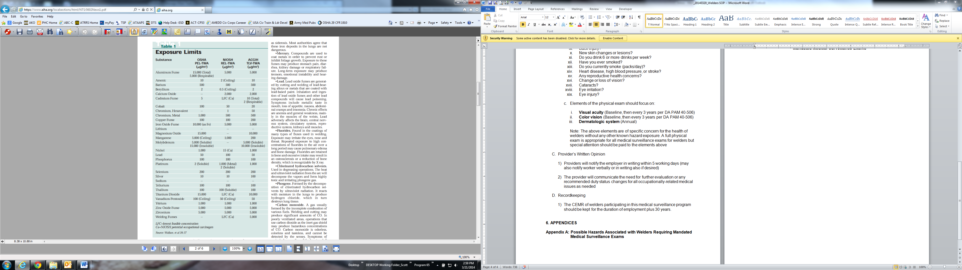

Sources: Wallace, M., et al. “In-Depth Survey Report: Control Technology Assessment for the Welding Operations.” Report No. ECTB 214-13a. Washington, DC: U.S. Dept. of Labor, OSHA. <http://osha.gov/SLTC/weldingcuttingbrazing/reportboilermakers/boilermakers.html>

Ashby, H.S. “Welding Fume in the Workplace.” *Professional Safety.* April 2002, pg. 55-60.